//creating and storing information in a file
#include<stdio.h>
#include<stdlib.h>

int main(){
FILE *f;
f= fopen("file.txt","w");
if(f==NULL){
printf("failed to create \n");
}
else{
printf("successfully created\n");
}
char name[30];
printf("enter your name:\n");
scanf("%[^\n]s",name);
fprintf(f,"%s",name);
return 0;
}
Output:


//reading the existing content of file
#include<stdio.h>
#include<stdlib.h>

int main(){
FILE *f;
f= fopen("file.txt","r");
if(f==NULL){
printf("failed to create \n");
}
else{
printf("successfully created\n");
}
char name[30];
fscanf(f,"%s",name);
printf("%s",name);
return 0;
}

Output:

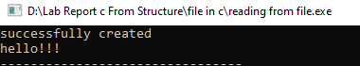
//writing multiple lines in file

#include<stdio.h>
#include<stdlib.h>

int main(){
FILE *f;
f=fopen("file1.txt","w");
if(f==NULL){
printf("file creation unsuccessful\n");
}
else{
printf("file creation successful\n");
}
int n;
printf("how many line do you wanna write:\n");
scanf("%d",&n);
char str[50];
int i;
for(i=1;i<=n;i++){
printf("enter %d line \n",i);
scanf("%s",str);
fprintf(f,"%s\n",str);
}
return 0;
}
Output:

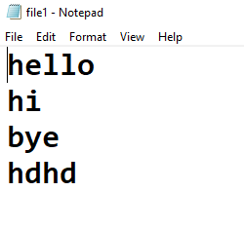
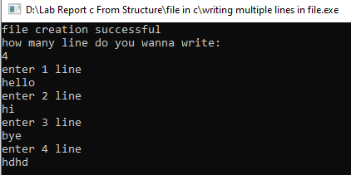

//reading multiple lines from file
#include<stdio.h>
#include<stdlib.h>
int main(){
FILE *f;
f=fopen("file1.txt","r");
if(f==NULL){
printf("file creation unsuccessful\n");
}
else{
printf("file creation successful\n");
}
char name[50];
while(fgets(name,50,f)!=0){
printf("%s\n",name);
}
fclose(f);
FILE *p;
p=fopen("file2.txt","r");
if(p==NULL){
printf("file creation unsuccessful\n");
}
else{
printf("file creation successful\n");
}
int n;
while(fscanf(p,"%d",&n)==1){
printf("%d\n",n);
}
fclose(p);
return 0;
}
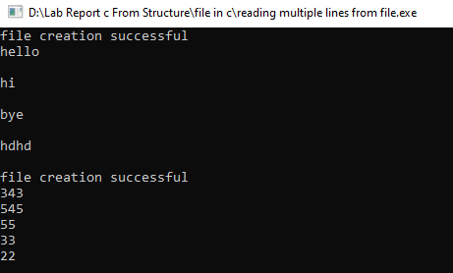
Output:
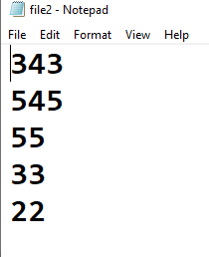


//WAP to input 10 numbers from user and store it on a file named odd.txt and read that file and print only odd number
#include<stdio.h>
#include<stdlib.h>
int main(){
FILE *f;
f = fopen("odd.txt","w");
if(f==NULL){
printf("failed to create file\n");
}
else{
printf("successfully opened file\n");
}
int n[10],i;
printf("enter any 10 numbers\n");
for(i=0;i<10;i++){
scanf("%d",&n[i]);
fprintf(f,"%d\n",n[i]);
}
fclose(f);
FILE *p;
f = fopen("odd.txt","r");
p = fopen("write.txt","w");
if(p==NULL){
printf("failed to create file\n");
}
else{
printf("successfully opened file\n");
}
int a;
while(fscanf(f,"%d",&a)==1){
if(a%2!=0){
printf("odd value : %d\n",a);
fprintf(p,"%d\n",a);
}
}
fclose(f);
return 0;
}

Output:
